CHAPTER THREE

SYSTEM ANALYSIS AND DESIGN

3.1 Analysis of the Existing System
The existing system refers to the manual, paper-driven method of managing patient records and daily operations that is still in use in many Nigerian general and mission hospitals. Under this arrangement, every clinical and administrative activity is recorded on paper, and the movement of a patient through the hospital is tracked by the physical movement of a case file from one unit to another. A small number of hospitals operate partial computerisation, usually limited to a stand-alone billing register or a spreadsheet kept by the records officer, but these are not connected to the clinical units and therefore do not change the underlying paper workflow.

3.1.1 Actors in the Existing System
The actors in the existing system are the records officer, the receptionist, the doctor, the nurse, the pharmacist, the laboratory technician, the accounts officer and the hospital administrator. The records officer keeps custody of the case file cabinet and is responsible for retrieving and returning folders. The receptionist registers new patients and issues hospital numbers. The doctor examines the patient and writes findings, diagnosis and prescriptions into the case file by hand. The nurse records vital signs on a separate observation chart. The pharmacist dispenses drugs against a handwritten prescription slip and records the transaction in a dispensary ledger. The laboratory technician receives handwritten test requests and returns results on printed or handwritten result slips that are later filed into the case file. The accounts officer raises bills manually and issues receipts from a receipt booklet. The hospital administrator relies on periodic manual counts submitted by each unit to know what is happening in the hospital.

3.1.2 Workflow of the Existing System
A patient visiting the hospital for the first time reports to the reception, where personal and demographic details are written into a registration register and a hospital number is assigned. A case file is opened and sent to the consulting room. A returning patient states the hospital number at the records unit, and the records officer searches the cabinet for the folder before it is carried to the consulting room. The patient then waits until the file arrives and the doctor becomes available.
During consultation, the doctor reads the previous entries in the file, writes the current complaint, examination findings and diagnosis, and issues handwritten requests for laboratory investigations or a prescription. The patient carries the request slip physically to the laboratory or the pharmacy. Laboratory results are returned to the consulting room by the patient or by a ward attendant, and the doctor writes the final treatment plan after seeing them. Billing takes place at the accounts unit, where the officer calculates charges for consultation, drugs and tests from the slips presented by the patient, collects payment and issues a receipt. At the end of the day, each unit compiles its own tally of patients seen, drugs dispensed and revenue collected, and these tallies are submitted to the administrator, who combines them manually to produce monthly reports.

3.1.3 Limitations of the Existing System
The most immediate weakness of this arrangement is the time spent retrieving records. Because a folder can only be in one place at a time, a patient cannot be attended to until the physical file is found and delivered, and when a folder is misfiled or has been carried to another unit and not returned, the search can take a considerable part of the consultation period. In extreme cases the folder is never found, and a fresh file is opened for a patient who already exists in the register. This is the direct cause of duplicate records, and it means that the clinical history of one patient becomes split across two or more folders, none of which is complete.
Paper records are also fragile. Files are exposed to damp, insects, fire and ordinary wear, and once a page is lost there is no second copy. There is no meaningful access control either, since anyone who can reach the cabinet or who is handed a folder can read every entry in it. Confidentiality therefore depends entirely on the honesty of whoever is holding the file, and there is no record of who read what, or when.
Handwriting introduces a further class of problems. Entries that cannot be read clearly are interpreted differently by the pharmacist and the doctor who wrote them, and drug names, dosages and test names are the entries most often misread. Transcription of the same information into several places, the case file, the dispensary ledger, the laboratory register and the billing booklet, multiplies the opportunity for error and means that the four records rarely agree with one another.
Communication between units is slow because it depends on the patient walking documents from one point to another. A laboratory result that is ready is of no use until it physically reaches the consulting room, and a doctor has no way of knowing that it is ready. Appointment scheduling suffers from the same limitation, as appointments are written in a diary at the reception that the doctor cannot see and that is not checked against the doctor's availability, so patients are booked to arrive at the same time and are attended to on a first-come basis regardless of the appointment.
Finally, reporting is laborious and unreliable. Producing a simple figure such as the number of patients treated for a particular condition in a quarter requires someone to open and count folders one at a time, which in practice is not done, so administrative decisions are taken on the basis of estimates. Revenue reconciliation has the same difficulty, since receipts, dispensary entries and consultation records must be compared by hand before the true position is known.

3.2 Analysis of the Proposed System
The proposed system is a web-based Hospital Management System named VITALS, designed to replace the paper-driven workflow described above with a single centralised database that every hospital unit reaches through a web browser. Rather than moving a folder between units, the system moves the user to the record: a doctor, pharmacist, laboratory technician or receptionist signs into the same application and sees the portion of the patient's record that the assigned role permits. The design is built around role-based access control, so that what a user can see and do is determined by the role stored on the user account rather than by physical possession of a document.

3.2.1 Actors and Roles in the Proposed System
Six roles are defined in the system, held as an enumerated field on the user account: administrator, doctor, nurse, pharmacist, laboratory technician and receptionist.
The administrator creates and edits user accounts, sets each account's role and status, manages doctor and staff profiles, manages departments, and is the only role able to open the reports module. The receptionist registers patients, searches and updates patient details, books and cancels appointments, views the doctor directory, and handles billing, that is, raising bills and recording payments against them. The doctor views the patients list and the day's appointments, records medical records comprising symptoms, diagnosis, treatment and follow-up date, issues prescriptions and raises laboratory requests, and views the drug inventory and test catalogue in read-only form in order to prescribe and request accurately. The nurse views patients and appointments and may create and update appointments, but cannot create medical records, prescriptions or laboratory requests. The pharmacist manages the drug inventory and dispenses pending prescriptions. The laboratory technician manages the test catalogue and enters results against pending laboratory requests.
Access control is applied in two places. A proxy layer intercepts every request other than the public landing, login and signup pages and redirects any request without a valid session token to the login page. Beyond that first check, each protected page and each mutation re-verifies the session and compares the user's role against the roles permitted for that operation, redirecting to a forbidden page where the role does not match. A pharmacist who attempts to open a patient's medical record, or a nurse who attempts to dispense a prescription, is refused at the operation itself and not merely hidden from the menu. The navigation sidebar is generated from the same role map, so each user is shown only the modules the role can reach.
Table 3.1 sets out the role-to-module mapping enforced by the system.
Module | Admin | Doctor | Nurse | Pharm. | Lab Tech. | Recep.
Dashboard | F | F | F | F | F | F
Patients | F | F | F | — | — | F
Appointments | F | V | F | — | — | F
Doctor directory | F | — | — | — | — | V
Medical records | F | C | — | — | — | —
Prescriptions | F | C | — | D | — | —
Drug inventory | F | V | — | F | — | —
Laboratory requests | F | C | — | — | R | —
Test catalogue | F | V | — | — | F | —
Billing and invoices | F | — | — | — | — | F
Staff profiles | F | — | — | — | — | —
Departments | F | — | — | — | — | —
User accounts | F | — | — | — | — | —
Reports | F | — | — | — | — | —
Table 3.1: Role-to-module access matrix of the proposed system
Key: F = full access within the module; V = view only; C = may create records; D = may dispense; R = may enter results; — = no access.

3.2.2 Improvements Over the Existing System
Record retrieval is reduced from a physical search of a cabinet to a database query on the patient number, name or phone number, and the record is returned in seconds to any authorised user. Because each patient record carries a unique patient number and the collection enforces that uniqueness, and because the register is searchable before a new record is created, the duplication that arises from unfound folders is prevented.
Loss and damage are addressed by storing records in a MongoDB database that can be backed up on a schedule, so that a single physical accident does not destroy a patient's history. Confidentiality is enforced by authentication and by the two-stage role check described above, and an audit log collection records the acting user, the action, the module, the affected record and a timestamp, which the manual system cannot provide at all.
Legibility problems disappear because medical records, prescriptions and laboratory requests are typed and stored as structured fields rather than handwritten. Drugs are selected from the drug inventory and tests from the test catalogue rather than written out, and dosage, quantity and instructions are entered into defined fields, so the pharmacist reads exactly what the doctor entered. Transcription errors are also removed, since the prescription the doctor creates is the same document the pharmacist dispenses against, and the quantity dispensed is deducted from the same drug document that priced it.
Communication between units becomes immediate. A laboratory request raised by a doctor appears at once in the laboratory technician's request list, and once results are entered the request status advances and the results are visible to the requesting doctor without the patient carrying anything. Appointment booking is checked against existing appointments for the same doctor, date and time, and a clashing booking is rejected with an explanatory message, so two patients cannot be scheduled into the same slot.
Reporting, which was previously a manual counting exercise, becomes a query over stored data. The administrator can obtain patient, appointment, pharmacy, laboratory, staff and revenue reports over a chosen date range, and the figures are derived from the same documents the clinical and reception units created during their normal work, so reconciliation is no longer necessary.
It should be noted that the proposed system is a prototype developed for academic purposes. It implements the core administrative and clinical record functions described in this chapter but is not intended to serve as a fully deployed hospital information system.

3.3 Architecture of the Proposed System
VITALS is built as a three-tier web application. The presentation tier is a set of React components rendered by Next.js, the application tier consists of Server Components and Server Actions executing on the Node.js runtime, and the data tier is a MongoDB database accessed through Mongoose. The three tiers are not separate deployments; Next.js compiles them into one application in which server-side code and client-side code are written in the same TypeScript project and separated by explicit boundaries rather than by a network API. There is therefore no separate REST layer for internal use: a form in the browser invokes a Server Action directly, and the action performs the authorisation check, the validation and the database write.
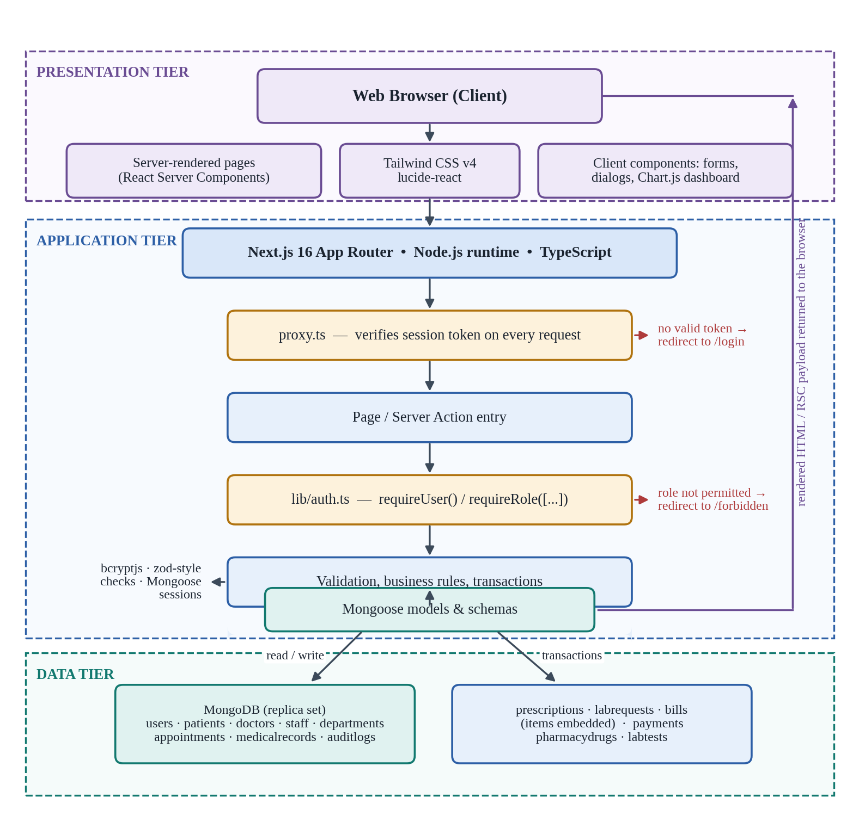
Figure 3.1: Three-tier architecture of the proposed system

3.3.1 Frontend Architecture
The presentation tier is built with React 19 under the Next.js App Router. Pages are Server Components by default, which means the page function runs on the server, awaits its data from the database and returns finished markup to the browser; only components that need browser state, such as forms, dialogs and the dashboard charts, are marked as client components. This keeps the amount of JavaScript sent to the browser small, which matters in a hospital setting where the terminals in the records and dispensary units are often older machines.
The authenticated area of the application shares a single layout that renders a navigation bar and a sidebar around each page. The sidebar is built from a role map that lists, for each module, the roles permitted to see it, so a nurse and a pharmacist signing in from the same computer are presented with different menus. Shared interface elements, cards, badges, statistic cards, page headers, alerts, selects, date pickers and confirmation dialogs, are implemented once as components and reused across the modules, which keeps the interface consistent between units. Styling is written with Tailwind CSS v4 utility classes, icons are drawn from lucide-react, and the dashboard charts are rendered with Chart.js through react-chartjs-2.

3.3.2 Backend Architecture
The application tier runs on the Node.js runtime under Next.js 16, written in TypeScript. Mutations are implemented as Server Actions grouped by module, one file each for authentication, patients, doctors, staff, users, departments, appointments, medical records, pharmacy, laboratory, billing and profile. A Server Action begins by enforcing the role required for that operation, then validates the submitted form data, then performs the database work, and finally redirects with a success or error message. Because the authorisation call is the first statement in the action, an operation cannot be reached by submitting a request directly to the server without passing the same check that guards the page.
Authentication is token-based. Passwords are hashed with bcryptjs before being stored and are never held in plain text. On successful login the server signs a token containing the user's identifier, name, email and role, and stores it in an httpOnly cookie with an eight-hour lifetime, so the token cannot be read by scripts running in the browser. A proxy module verifies the token on every request except the landing, login and signup routes and redirects unauthenticated visitors to the login page, preserving the requested path so the user is returned to it after signing in. Helper functions in the authentication library provide the second stage of the check: one returns the current user or redirects to login, and another accepts the list of roles permitted for an operation and redirects to a forbidden page when the user's role is not among them.
Account creation supports two paths. An administrator may create an account directly and set its role, including the administrator role itself. Alternatively a member of staff may request an account through the public signup page, choosing any role except administrator; the system hashes the password, generates a six-digit code, sends it to the submitted email address through the Resend service, and holds the pending details in a short-lived signed cookie rather than in the database. The user record is only created after the code is verified, and it is created with an inactive status so that an administrator must activate the account before the holder can sign in. This prevents a self-registered account from gaining access before it has been approved.
Two operations require more than one document to change together and are therefore wrapped in a Mongoose session and executed as multi-document transactions. Dispensing a prescription must deduct the dispensed quantity from every drug in the prescription and set the prescription status in one atomic step, and recording a payment must insert the payment document and update the parent bill's status together. Where one part of either operation fails, the transaction is rolled back and no partial change is left behind.

3.3.3 Database Design
The data tier is a MongoDB database accessed through Mongoose, which supplies the schema definitions, type checking and population that the database itself does not enforce. The connection is established lazily on first use and cached on the global object so that a single connection is reused across requests in development rather than a new one being opened on every reload.
The collections are users, patients, doctors, staff, departments, appointments, medicalrecords, prescriptions, pharmacydrugs, labtests, labrequests, bills, payments and auditlogs. The schema is deliberately not a direct translation of a relational design. Line items that are always read through their parent and are never queried on their own are embedded as subdocuments rather than kept as separate collections: prescription items holding the drug reference, dosage, quantity and instructions are embedded in the prescription; laboratory request items holding the test reference, result, notes, status and processing time are embedded in the request; and bill items holding the description, category, quantity, unit price and line total are embedded in the bill. Everything referenced from more than one context remains a top-level collection and is linked by object identifier, which Mongoose resolves on read through population.
The users collection holds the account, the hashed password, the role and the account status. A doctor or a member of non-clinical staff has an additional profile document, in the doctors or staff collection, that references the user and carries the department, specialisation or role title. Patients carry a unique patient number together with demographic and next-of-kin details, the assigned doctor and the user who registered them. Appointments reference a patient, a doctor and a department and carry a generated appointment number, a date, a time and a status of scheduled, completed, cancelled or no-show. Medical records, prescriptions and laboratory requests each reference the patient, the doctor and, where applicable, the appointment, which preserves the link between a consultation and the treatment ordered from it. Bills reference the patient and optionally the appointment and carry a subtotal, a discount, a total and a status of unpaid, partial or paid, while each payment references its bill. Because MongoDB does not enforce foreign keys, referential integrity is checked explicitly in the Server Actions: a patient cannot be deleted while appointments, medical records, prescriptions, laboratory requests or bills still reference the record, and deleting a user cascades to that user's doctor or staff profile inside a transaction.

3.4 Functional Requirements of the Proposed System
The functional requirements of VITALS are stated below and grouped according to the role that performs them.
General requirements
1. The system shall require every user to authenticate with an email address and password before access is granted.
2. The system shall store all passwords in hashed form using bcryptjs and shall never store or display a password in plain text.
3. The system shall issue a signed session token on successful login, store it in an httpOnly cookie and expire it after eight hours.
4. The system shall verify the session token on every request other than the landing, login and signup pages and redirect unauthenticated requests to the login page.
5. The system shall re-verify the session and the user's role within each protected page and each mutation, and redirect to a forbidden page where the role is not permitted.
6. The system shall generate each user's navigation menu from the modules that user's role is permitted to reach.
7. The system shall allow a prospective user to request an account, verify the email address with a six-digit code, and create the account with an inactive status pending administrator approval.
8. The system shall prevent an account with an inactive status from signing in.
9. The system shall record the acting user, action, module, affected record and timestamp for auditable operations.
10. The system shall terminate the session on logout.
Administrator
11. The system shall allow the administrator to create user accounts and assign any of the six roles to an account.
12. The system shall allow the administrator to edit a user account and to change its status between active and inactive.
13. The system shall prevent an administrator from deleting his or her own account.
14. The system shall allow the administrator to create and manage doctor profiles, including specialisation, qualification and department.
15. The system shall allow the administrator to create and manage non-clinical staff profiles and assign them to departments.
16. The system shall allow the administrator to create and manage departments and assign a head of department.
17. The system shall prevent the deletion of a record that is still referenced by other records, and shall inform the user why the deletion was refused.
18. The system shall allow the administrator to view a dashboard showing patient, appointment, revenue and inventory summaries.
19. The system shall allow the administrator to generate patient, appointment, pharmacy, laboratory, staff and revenue reports over a selected date range.
Receptionist
20. The system shall allow the receptionist to register a new patient and shall generate a unique patient number for each patient.
21. The system shall allow the receptionist to search for a patient by name, patient number or phone number.
22. The system shall allow the receptionist to update a patient's demographic and next-of-kin details and assign a doctor to the patient.
23. The system shall allow the receptionist to book an appointment for a patient with a selected doctor at a chosen date and time.
24. The system shall reject an appointment where the selected doctor already has a scheduled appointment at the same date and time.
25. The system shall allow the receptionist to reschedule, cancel or mark the status of an appointment.
26. The system shall allow the receptionist to view the directory of doctors and their departments.
27. The system shall allow the receptionist to raise a bill for a patient made up of consultation, laboratory, pharmacy and other items, and shall compute the subtotal, apply any discount and derive the total.
28. The system shall allow the receptionist to record full or part payments against a bill and shall reject a payment greater than the outstanding balance.
29. The system shall set a bill's status to unpaid, partial or paid according to the total recorded against it.
30. The system shall produce a printable invoice for a bill.
Doctor
31. The system shall present each doctor with a dashboard and with the appointments scheduled for that doctor.
32. The system shall allow a doctor to view a patient's record, including previous medical records, prescriptions and laboratory requests.
33. The system shall allow a doctor to create a medical record against a patient and appointment, comprising symptoms, diagnosis, treatment, prescription notes and a follow-up date.
34. The system shall allow a doctor to issue a prescription containing one or more drugs, each with a dosage, quantity and instructions, selected from the drug inventory.
35. The system shall allow a doctor to raise a laboratory request containing one or more tests selected from the test catalogue.
36. The system shall allow a doctor to view the drug inventory and the test catalogue without permitting the doctor to modify them.
37. The system shall make completed laboratory results visible to the requesting doctor.
Nurse
38. The system shall allow a nurse to view the patients list and patient records.
39. The system shall allow a nurse to create, update and view appointments.
40. The system shall prevent a nurse from creating medical records, prescriptions or laboratory requests.
Pharmacist
41. The system shall allow the pharmacist to add drugs to the inventory and to update a drug's category, unit, unit price, quantity in stock and reorder level.
42. The system shall present the pharmacist with the list of prescriptions and their pending or dispensed status.
43. The system shall allow the pharmacist to dispense a pending prescription, deducting the dispensed quantity of each drug from stock and setting the prescription status to dispensed in a single atomic operation.
44. The system shall refuse to dispense a prescription where the stock of any prescribed drug is insufficient, and shall name the drugs concerned.
45. The system shall refuse to dispense a prescription that has already been dispensed.
46. The system shall highlight drugs whose quantity in stock has fallen to or below the reorder level.
Laboratory Technician
47. The system shall allow the laboratory technician to add and maintain tests in the catalogue, including the normal range, unit and price.
48. The system shall present the laboratory technician with the list of laboratory requests and their statuses.
49. The system shall allow the laboratory technician to enter a result and result notes against each test in a request and mark that test as completed.
50. The system shall set a request's status to requested, processing or completed according to how many of its tests have results entered.

3.5 Methodology of the Study
The study adopts the Agile software development methodology, implemented in short iterations, with each iteration delivering a working part of the system. Agile was chosen in preference to the waterfall model because the requirements of a hospital management system are not fully understood at the outset and become clearer as each module is built and reviewed. The waterfall model requires that requirements and design be frozen before implementation begins, which would not have accommodated the changes that arose during this work. The most significant of these was the decision, taken after the first iteration had produced a complete working prototype, to rebuild the application on a different technology stack; under a waterfall plan that decision would have invalidated the whole design phase, whereas under Agile it was absorbed as the beginning of the next iteration. Agile also suits a project carried out by a single developer within one academic session, since the system can be demonstrated module by module rather than remaining untestable until the end. The phases below were carried out within that iterative structure and were revisited at each iteration.

3.5.1 Planning and Requirement Gathering
The first phase established what the system needed to do. The manual workflow described in Section 3.1 was studied through observation of hospital record and consultation procedures and through the review of published work on hospital information systems presented in Chapter Two. The problems identified there were translated into the six roles described in Section 3.2.1 and the numbered requirements listed in Section 3.4. The requirements were grouped into modules, authentication and user management, patients, doctors and staff, departments, appointments, medical records, pharmacy, laboratory, billing and reports, and the modules were ordered so that those the others depend upon were built first.

3.5.2 System Design
In the design phase the architecture described in Section 3.3 was fixed and the data model was drawn. Entities and their attributes were identified from the requirements and the relationships between them established. The role-to-operation mapping was defined at this stage, so that access control could be designed into the routing and the mutation layer rather than added afterwards. Unified Modelling Language diagrams were produced to describe the system before coding began, and these are presented in Sections 3.6 to 3.10. Interface layouts for the shared application shell and for each role's landing view were sketched so that the reusable components could be planned.

3.5.3 Implementation
Implementation was carried out in Visual Studio Code and proceeded in two iterations.
The first iteration produced a complete working prototype using Node.js with the Express framework, EJS templates and a MySQL database in a Model-View-Controller structure, with session-based authentication and role-checking middleware. That build implemented authentication, patients, doctors, staff, departments, appointments, pharmacy, laboratory and billing, and it established the data model and the role map that the present system still uses. It is retained in the project repository as a reference version and is not part of the running application.
Reviewing that prototype exposed two limitations. Server-rendered EJS pages could not provide the interactive elements the dashboard and the multi-item prescription, laboratory request and billing forms needed without an increasing amount of untyped browser JavaScript; and the relational schema was a poor fit for those same multi-item documents, which were always read and written as a whole yet had to be stored and rejoined across separate tables. The second iteration therefore rebuilt the application on Next.js 16 with React 19 and TypeScript, replacing EJS templates with React components, MySQL with MongoDB through Mongoose, session cookies with a signed token in an httpOnly cookie, and Express controllers with Server Actions. Line-item tables became embedded subdocuments, and TypeScript gave compile-time checking of the shapes passed between the database, the actions and the components. The modules were rebuilt in the same dependency order as before, beginning with authentication and user management, since every other module depends on a session and a role being available, and each module was completed as a working unit before the next was started. Version control was used throughout to keep a history of the work and to allow a change to be reversed where it broke an existing module.

3.5.4 Testing
Testing was performed continuously rather than as a single stage at the end. Each module was tested as it was completed. Static checking was applied on every change through the TypeScript compiler and ESLint, which catch a class of defects, such as a field renamed in a schema but not at its point of use, before the application is run at all. Functional testing was carried out by exercising each module through the interface, and integration testing confirmed that modules sharing data behave correctly together, for example that dispensing a prescription reduces the correct drug quantities and that recording a payment moves the parent bill to the partial or paid status.
Access control was tested specifically. Signing in under each of the six roles, an attempt was made to reach each module belonging to the other roles, both through the interface and by requesting the route directly, and in each case the request was refused and redirected to the forbidden page. Input validation was tested with empty fields, invalid dates, quantities exceeding available stock and payments exceeding the outstanding balance, each of which returns a message rather than a partial write. The transactional operations were tested by forcing a failure part-way through dispensing and confirming that no stock had been deducted. Finally, the complete patient journey from registration through appointment, consultation, laboratory testing, dispensing and payment was run end to end to confirm that data entered at one point appears correctly at every later point.

3.5.5 Deployment and Evaluation
The system was deployed on a server running the Node.js production build with the MongoDB database reachable from it, accessible to client machines through a web browser, which reflects the way such a system would be installed in a hospital. Because the dispensing and payment operations use multi-document transactions, MongoDB is run as a replica set, a single-node replica set being sufficient for the prototype. A seeding script loads demonstration data covering departments, doctors, staff accounts for each role, patients, appointments, drugs, tests and bills, so that the system can be demonstrated realistically.
Evaluation was carried out by checking the completed system against the functional requirements in Section 3.4 one by one, and by comparing the time taken to complete common tasks, such as retrieving a patient's history and producing a monthly patient count, against the same tasks in the manual system. The results of this evaluation are presented in Chapter Four.

3.6 Use Case Diagram
The use case diagram presents the functions of VITALS from the point of view of the people who use it and shows which functions belong to which role. Six actors appear in the diagram: the Administrator, the Receptionist, the Doctor, the Nurse, the Pharmacist and the Laboratory Technician. Login is shown as a use case shared by all six actors, since no function in the system can be reached without it, and it is connected to every other use case by an include relationship to show that authentication and the role check precede every action.
The administrator's use cases are managing user accounts, managing doctor and staff profiles, managing departments and generating reports. The receptionist's use cases are registering and searching for patients, booking and cancelling appointments, viewing the doctor directory, raising bills and recording payments. The doctor's use cases are viewing patients and appointments, recording a medical record, issuing a prescription and requesting laboratory tests. The nurse views patients and manages appointments. The pharmacist manages the drug inventory and dispenses prescriptions. The laboratory technician manages the test catalogue and enters results.
The diagram makes the separation of duties visible. Where a use case is connected to more than one actor it is because the workflow requires it, as with viewing patients, which the administrator, doctor, nurse and receptionist all reach, and viewing prescriptions, which the doctor who issued them and the pharmacist who dispenses them both reach while only the pharmacist can dispense. This reflects the role-based access control that distinguishes the proposed system from the manual arrangement, where possession of a case file granted access to everything in it.
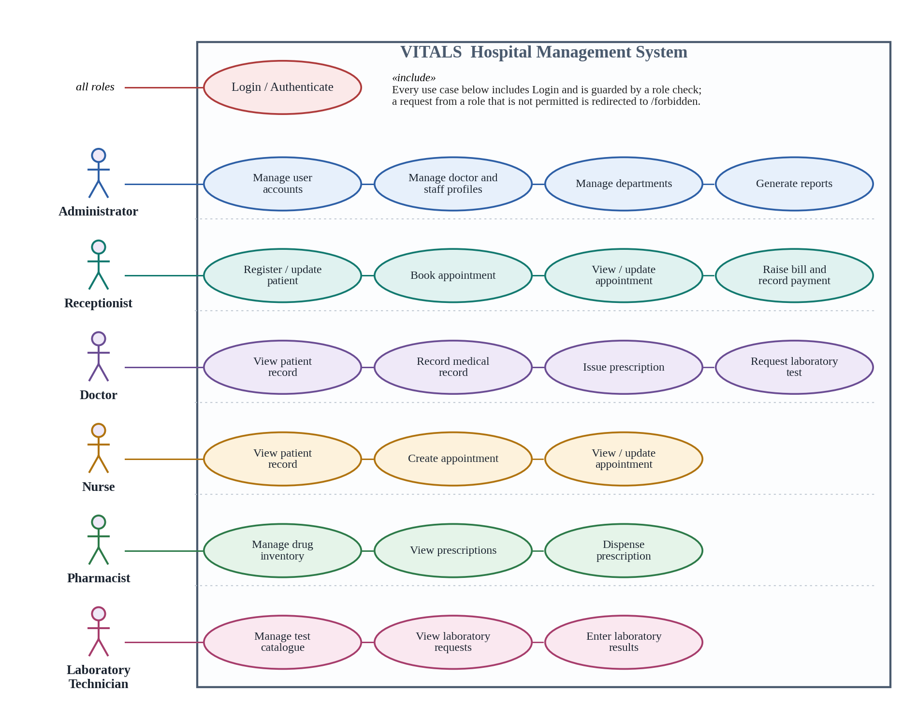
Figure 3.2: Use case diagram of the proposed system

3.7 Activity Diagrams
Activity diagrams are used to describe the sequence of actions and decisions within the principal workflows of the system. Four workflows are presented, each corresponding to a role whose activity is central to the operation of the hospital.

3.7.1 Activity Diagram for Patient Registration and Appointment Booking
This diagram describes the receptionist's workflow. The activity begins when a patient arrives at the reception and the receptionist signs in. The first decision point asks whether the patient is new or returning. For a returning patient the receptionist searches by name, patient number or phone number and the record is retrieved, with a second decision handling the case where no record is found, which returns the flow to the registration path. For a new patient the receptionist enters the demographic and next-of-kin details, the system generates a unique patient number, and the record is saved.
The flow continues to appointment booking, where the receptionist selects the doctor, the date and the time. A decision point checks whether that doctor already has a scheduled appointment at the same date and time; where a clash is found the booking is rejected with a message and the receptionist is returned to the slot selection. Where the slot is free, an appointment number is generated, the appointment is saved with the status scheduled, it becomes visible on the appointments list of the doctor concerned, and the activity ends with the patient being informed of the appointment details.
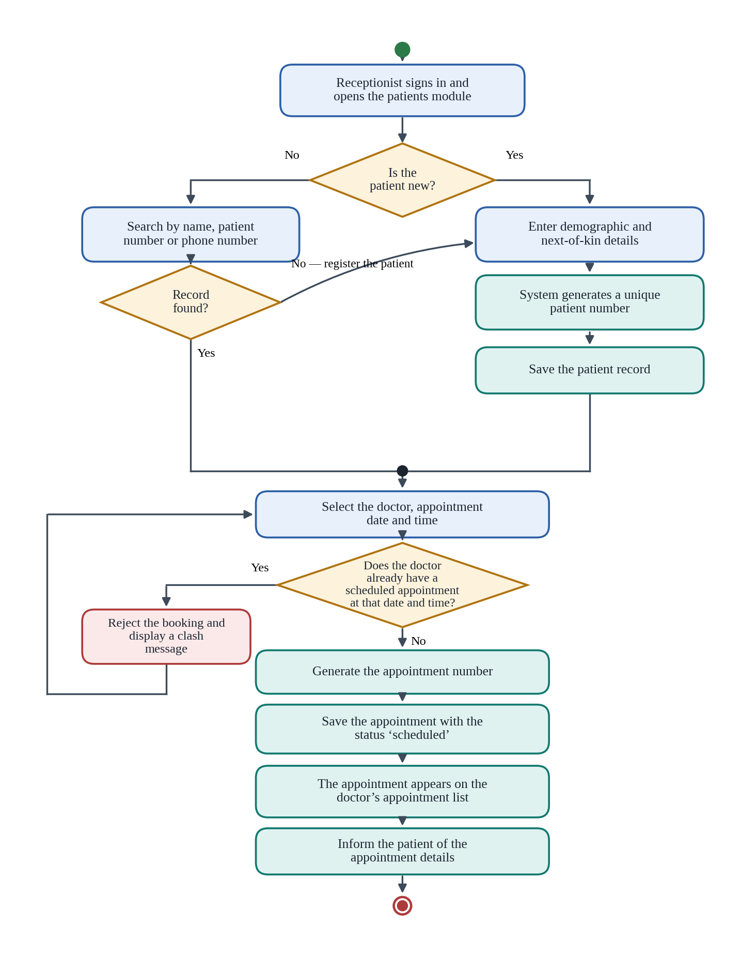
Figure 3.3: Activity diagram for patient registration and appointment booking

3.7.2 Activity Diagram for Doctor Consultation
This diagram describes the doctor's workflow. The activity begins when the doctor signs in and opens the appointments list. The doctor selects a patient, and the system displays the patient's record, comprising previous medical records, prescriptions and laboratory requests. The doctor records the symptoms, diagnosis and treatment and sets a follow-up date where one is needed.
A decision point then asks whether a laboratory investigation is required. If it is, the doctor selects the tests from the catalogue, the request is saved with the status requested and appears in the laboratory technician's list, and the consultation is left open pending results; when the results are entered the request status advances and the doctor returns to the record to complete it. If no investigation is required, or once the results have been received, a second decision asks whether medication is to be prescribed. Where it is, the doctor selects the drugs from the inventory, enters the dosage, quantity and instructions for each, and saves the prescription with the status pending, at which point it becomes visible to the pharmacist. The doctor then saves the medical record and the activity ends with the record stored against the patient.
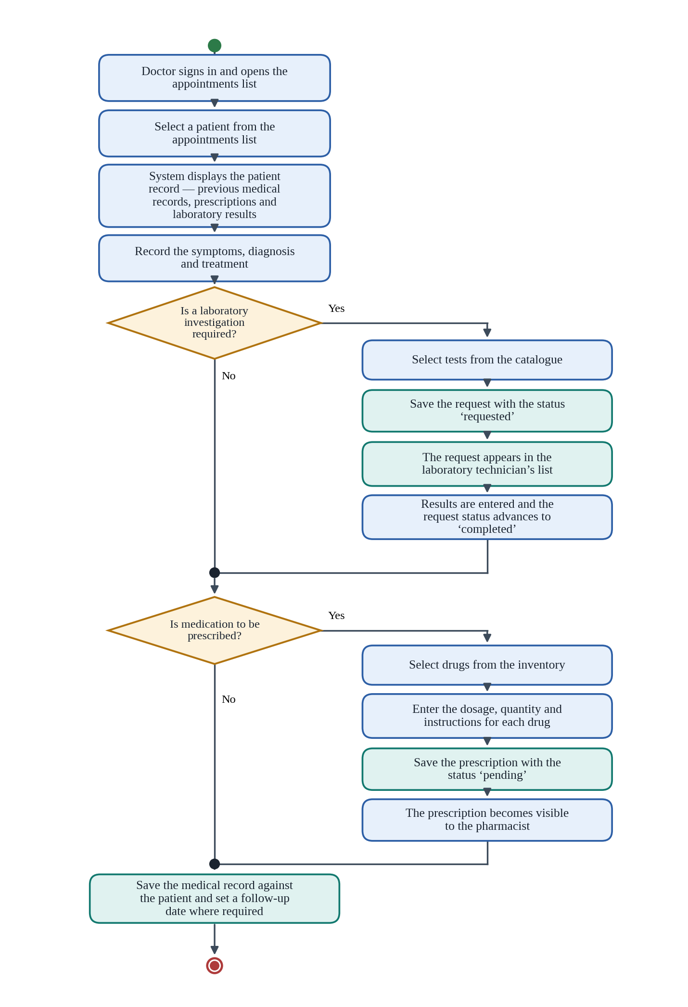
Figure 3.4: Activity diagram for doctor consultation

3.7.3 Activity Diagram for Pharmacy Dispensing
This diagram describes the pharmacist's workflow. The activity begins when the pharmacist signs in and opens the prescriptions list. The pharmacist selects a prescription, and the system displays the patient, the prescribing doctor and the drugs prescribed with their quantities. A first decision checks whether the prescription has already been dispensed, in which case the operation is refused and the flow ends. Otherwise a transaction is opened and the current stock of every drug in the prescription is read.
A second decision compares the quantity required for each drug against the quantity in stock. Where any drug is short, the transaction is abandoned, no stock is deducted, and the pharmacist is shown a message naming the drugs concerned. Where all quantities are available, the stock of each drug is reduced by the quantity prescribed and the prescription status is set to dispensed, both within the same transaction so that either all the changes take effect or none do. Drugs whose remaining quantity has fallen to or below the reorder level are highlighted in the inventory. The activity ends when the transaction is committed and the updated prescription is displayed.
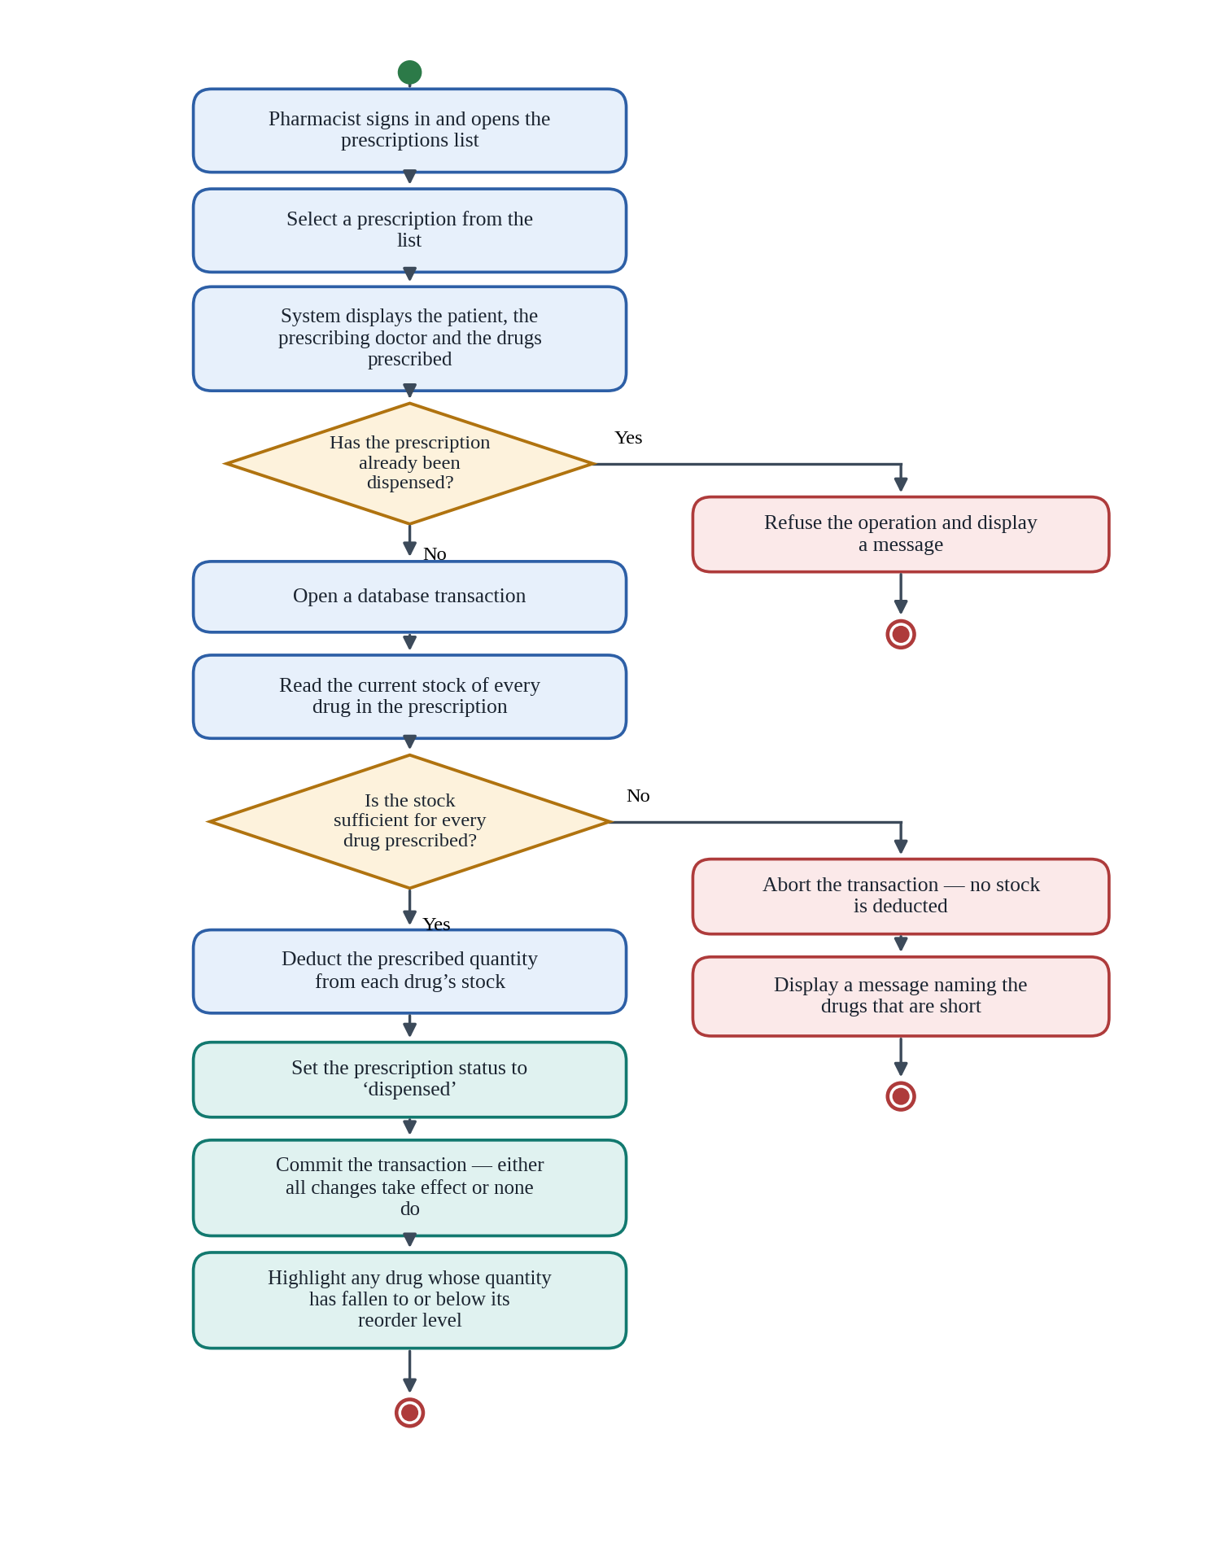
Figure 3.5: Activity diagram for pharmacy dispensing

3.7.4 Activity Diagram for Administrator User Management
This diagram describes the administrator's workflow for managing accounts. The activity begins when the administrator signs in and opens the users page, which lists existing accounts with their roles and statuses. A decision point separates the creation of a new account from the modification of an existing one.
To create an account the administrator enters the user's name, email address and password, and selects one of the six roles; the system checks that the email address is not already registered, hashes the password and saves the account with an active status, after which the user can sign in with the permissions of that role. Accounts arriving from the public signup route enter this workflow at a different point: they already exist but carry an inactive status, and the administrator's action is to review and activate them.
To modify an existing account the administrator selects it and chooses whether to edit its details, change its role or change its status. A change of role takes effect at the user's next sign-in, since the role is carried in the session token issued at login. Setting an account to inactive prevents further sign-in while retaining the records the user created, which is necessary because those records reference the user. A decision point prevents the administrator from deleting his or her own account, and deleting a user whose account has a doctor or staff profile removes that profile in the same transaction. The activity ends when the user list is refreshed.
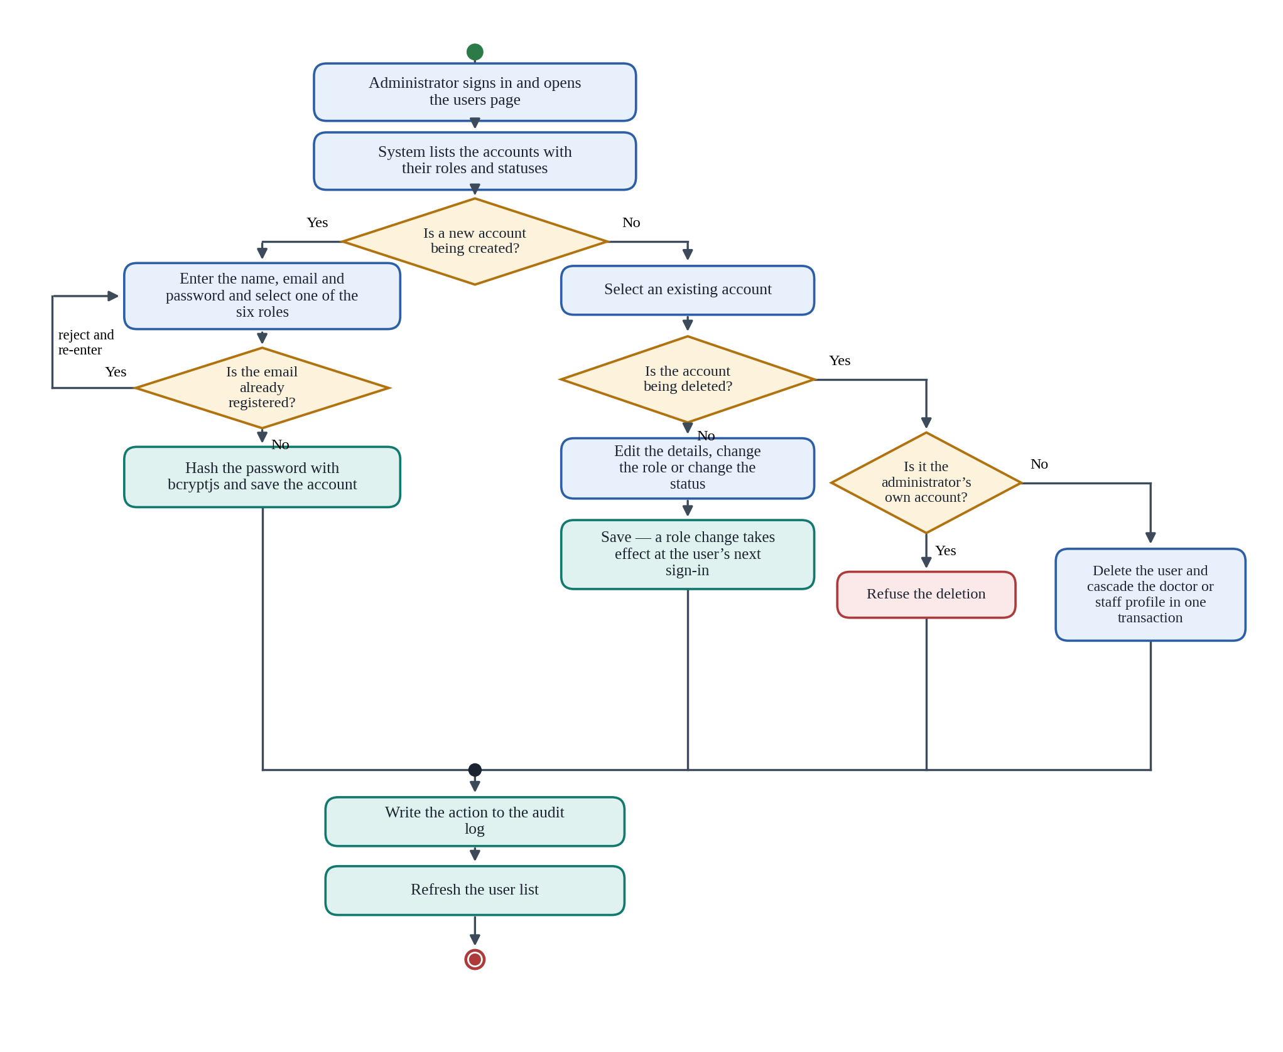
Figure 3.6: Activity diagram for administrator user management

3.8 Sequence Diagram
The sequence diagram shows the order in which the components of the system exchange messages during a single interaction, using login and role verification as the example, since it is the interaction on which every other function depends. Six participants appear along the top of the diagram: the User, the Browser, the Proxy layer, the Login Server Action, the Authentication Library and the MongoDB database.
The sequence begins when the user submits the login form, which invokes the login Server Action. The action validates that both fields have been supplied and queries the users collection for a document matching the submitted email address. The database returns the document, including the hashed password, the role and the account status. The action calls bcryptjs to compare the submitted password with the stored hash. Where no document is returned or the comparison fails, the action returns an error to the form without disclosing which of the two was wrong, and where the document is found but its status is inactive, the action returns a message stating that the account is awaiting administrator activation. Both outcomes are shown as alternative fragments in the diagram.
Where the comparison succeeds and the account is active, the action calls the authentication library to sign a token containing the user's identifier, name, email and role, and to set it as an httpOnly cookie with an eight-hour lifetime, after which the browser is redirected to the dashboard. The diagram then shows a second, shorter exchange representing any subsequent request to a protected page: the browser sends the request with the cookie, the proxy verifies the token and either redirects to login or allows the request through, and the page itself then calls the role check, which compares the role in the token against the roles permitted for that page and either renders the page or redirects to the forbidden page. This second exchange is included to show that authorisation is applied on every request and at two levels, rather than once at login.
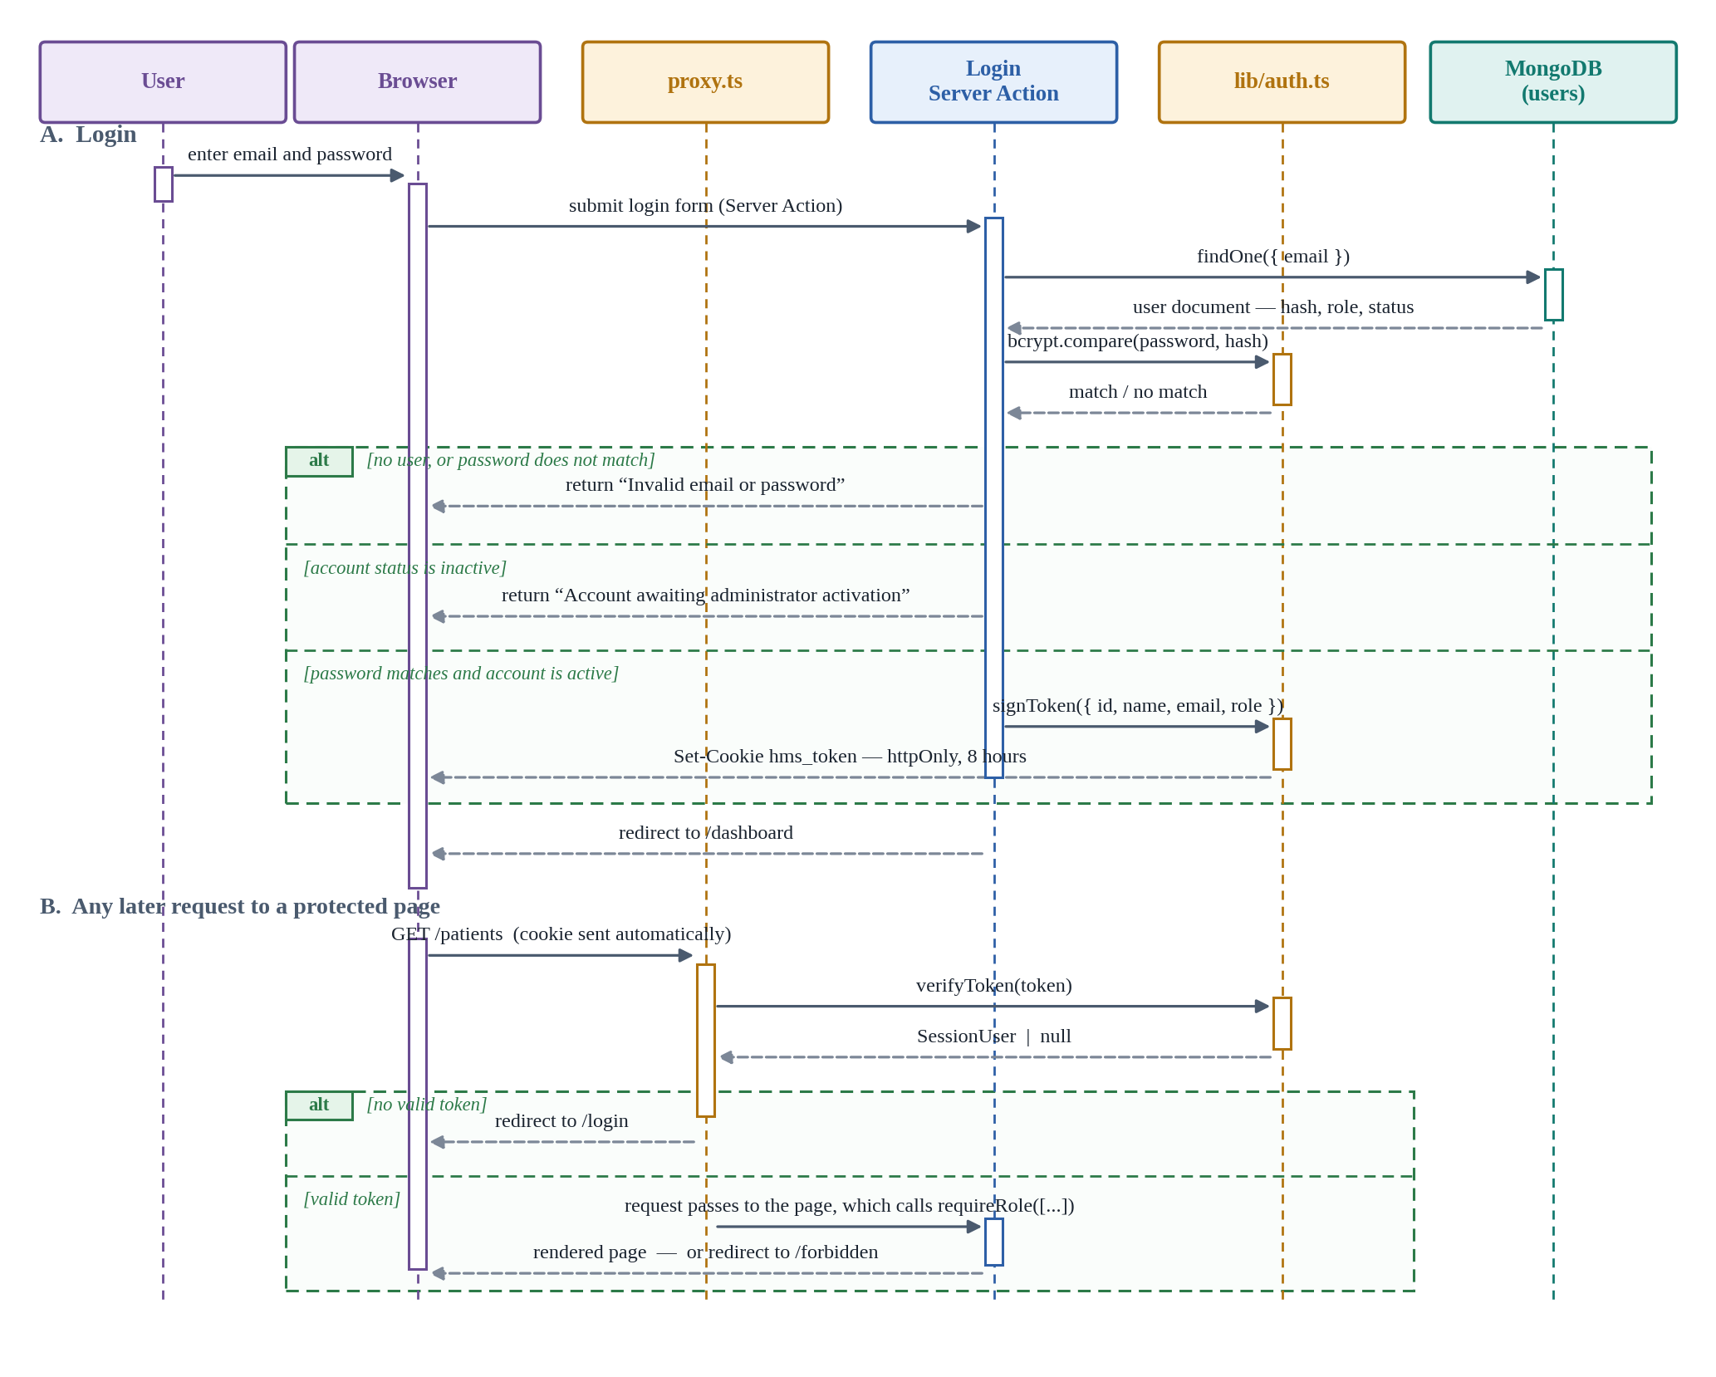
Figure 3.7: Sequence diagram for login and role verification

3.9 Class Diagram
The class diagram shows the model classes that make up the system, their attributes and operations, and the relationships between them. The principal classes are User, Patient, Doctor, Staff, Department, Appointment, MedicalRecord, Prescription, PrescriptionItem, PharmacyDrug, LabRequest, LabRequestItem, LabTest, Bill, BillItem, Payment and AuditLog.
The User class holds the name, email address, hashed password, role, status, phone number and date of birth, and its operations include authenticate, createAccount, updateAccount and setStatus. A User optionally has one Doctor profile or one Staff profile, each of which holds the department and the professional details for that user, and both Doctor and Staff are associated with Department. The Patient class holds the patient number, names, date of birth, gender, blood group, contact details and next-of-kin details, together with the assigned doctor and the user who registered the record, and its operations are register, search, update and getHistory.
Patient is associated with Appointment, MedicalRecord, Prescription, LabRequest and Bill, in each case as a one-to-many relationship. Appointment links a patient, a doctor and a department and carries the appointment number, date, time, type and status. MedicalRecord links a patient, a doctor and optionally an appointment and holds the symptoms, diagnosis, treatment, prescription notes and follow-up date.
Three classes are composed of embedded items, shown in the diagram as composition. Prescription is composed of one or more PrescriptionItem objects, each referencing a PharmacyDrug and holding the dosage, quantity and instructions, and its operations are create and dispense. LabRequest is composed of one or more LabRequestItem objects, each referencing a LabTest and holding the result, notes, status and processing time, with operations create and submitResults. Bill is composed of one or more BillItem objects holding the description, category, quantity, unit price and line total, and carries the subtotal, discount, total and status, with operations create and recalculateStatus. Payment is associated with Bill in a many-to-one relationship, allowing part payments, and PharmacyDrug carries the drug name, category, unit, unit price, quantity in stock and reorder level with operations reduceStock and isBelowReorderLevel. AuditLog is associated with User and records the action, module, affected record, IP address and timestamp.
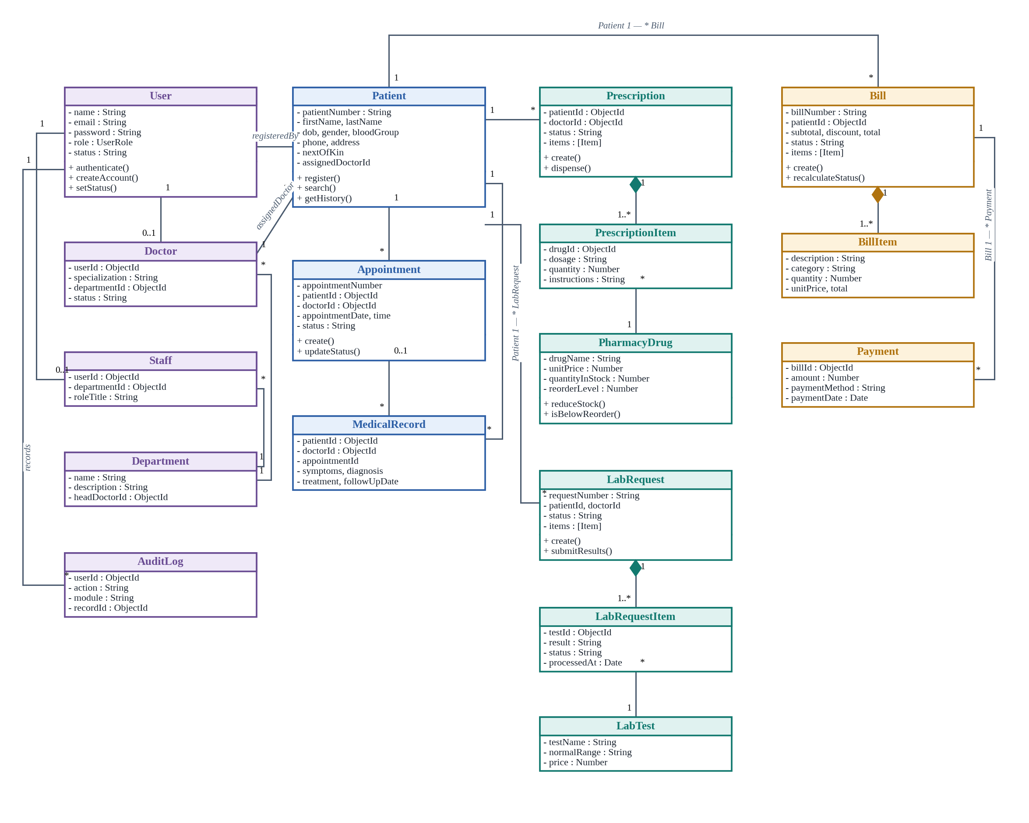
Figure 3.8: Class diagram of the proposed system

3.10 Database Schema Diagram
The database schema diagram presents the structure of the MongoDB database that supports the classes described above, showing the collections, their key fields and the references between them. Because MongoDB is a document database, the diagram distinguishes two kinds of relationship: a reference, in which one document stores the object identifier of a document in another collection, and an embedded array, in which the child documents are stored inside the parent document itself.
The users collection is referenced by the doctors and staff collections, each of which also references departments, and departments in turn references a doctor as its head. The patients collection references a doctor as the assigned doctor and a user as the registering officer. Appointments references patients, doctors and departments. Medicalrecords, prescriptions and labrequests each reference patients and doctors, and optionally an appointment. Bills references patients and optionally an appointment, and payments references bills. Auditlogs references users.
The prescriptions, labrequests and bills collections each hold an embedded array of items rather than pointing to a separate collection of line items: prescription items reference pharmacydrugs, laboratory request items reference labtests, and bill items hold their description and pricing inline. The pharmacydrugs and labtests collections are otherwise independent catalogues, referenced only from within those embedded arrays. Since MongoDB does not enforce referential integrity, the constraints implied by these references are checked in the application layer before a deletion is allowed, as described in Section 3.3.3.
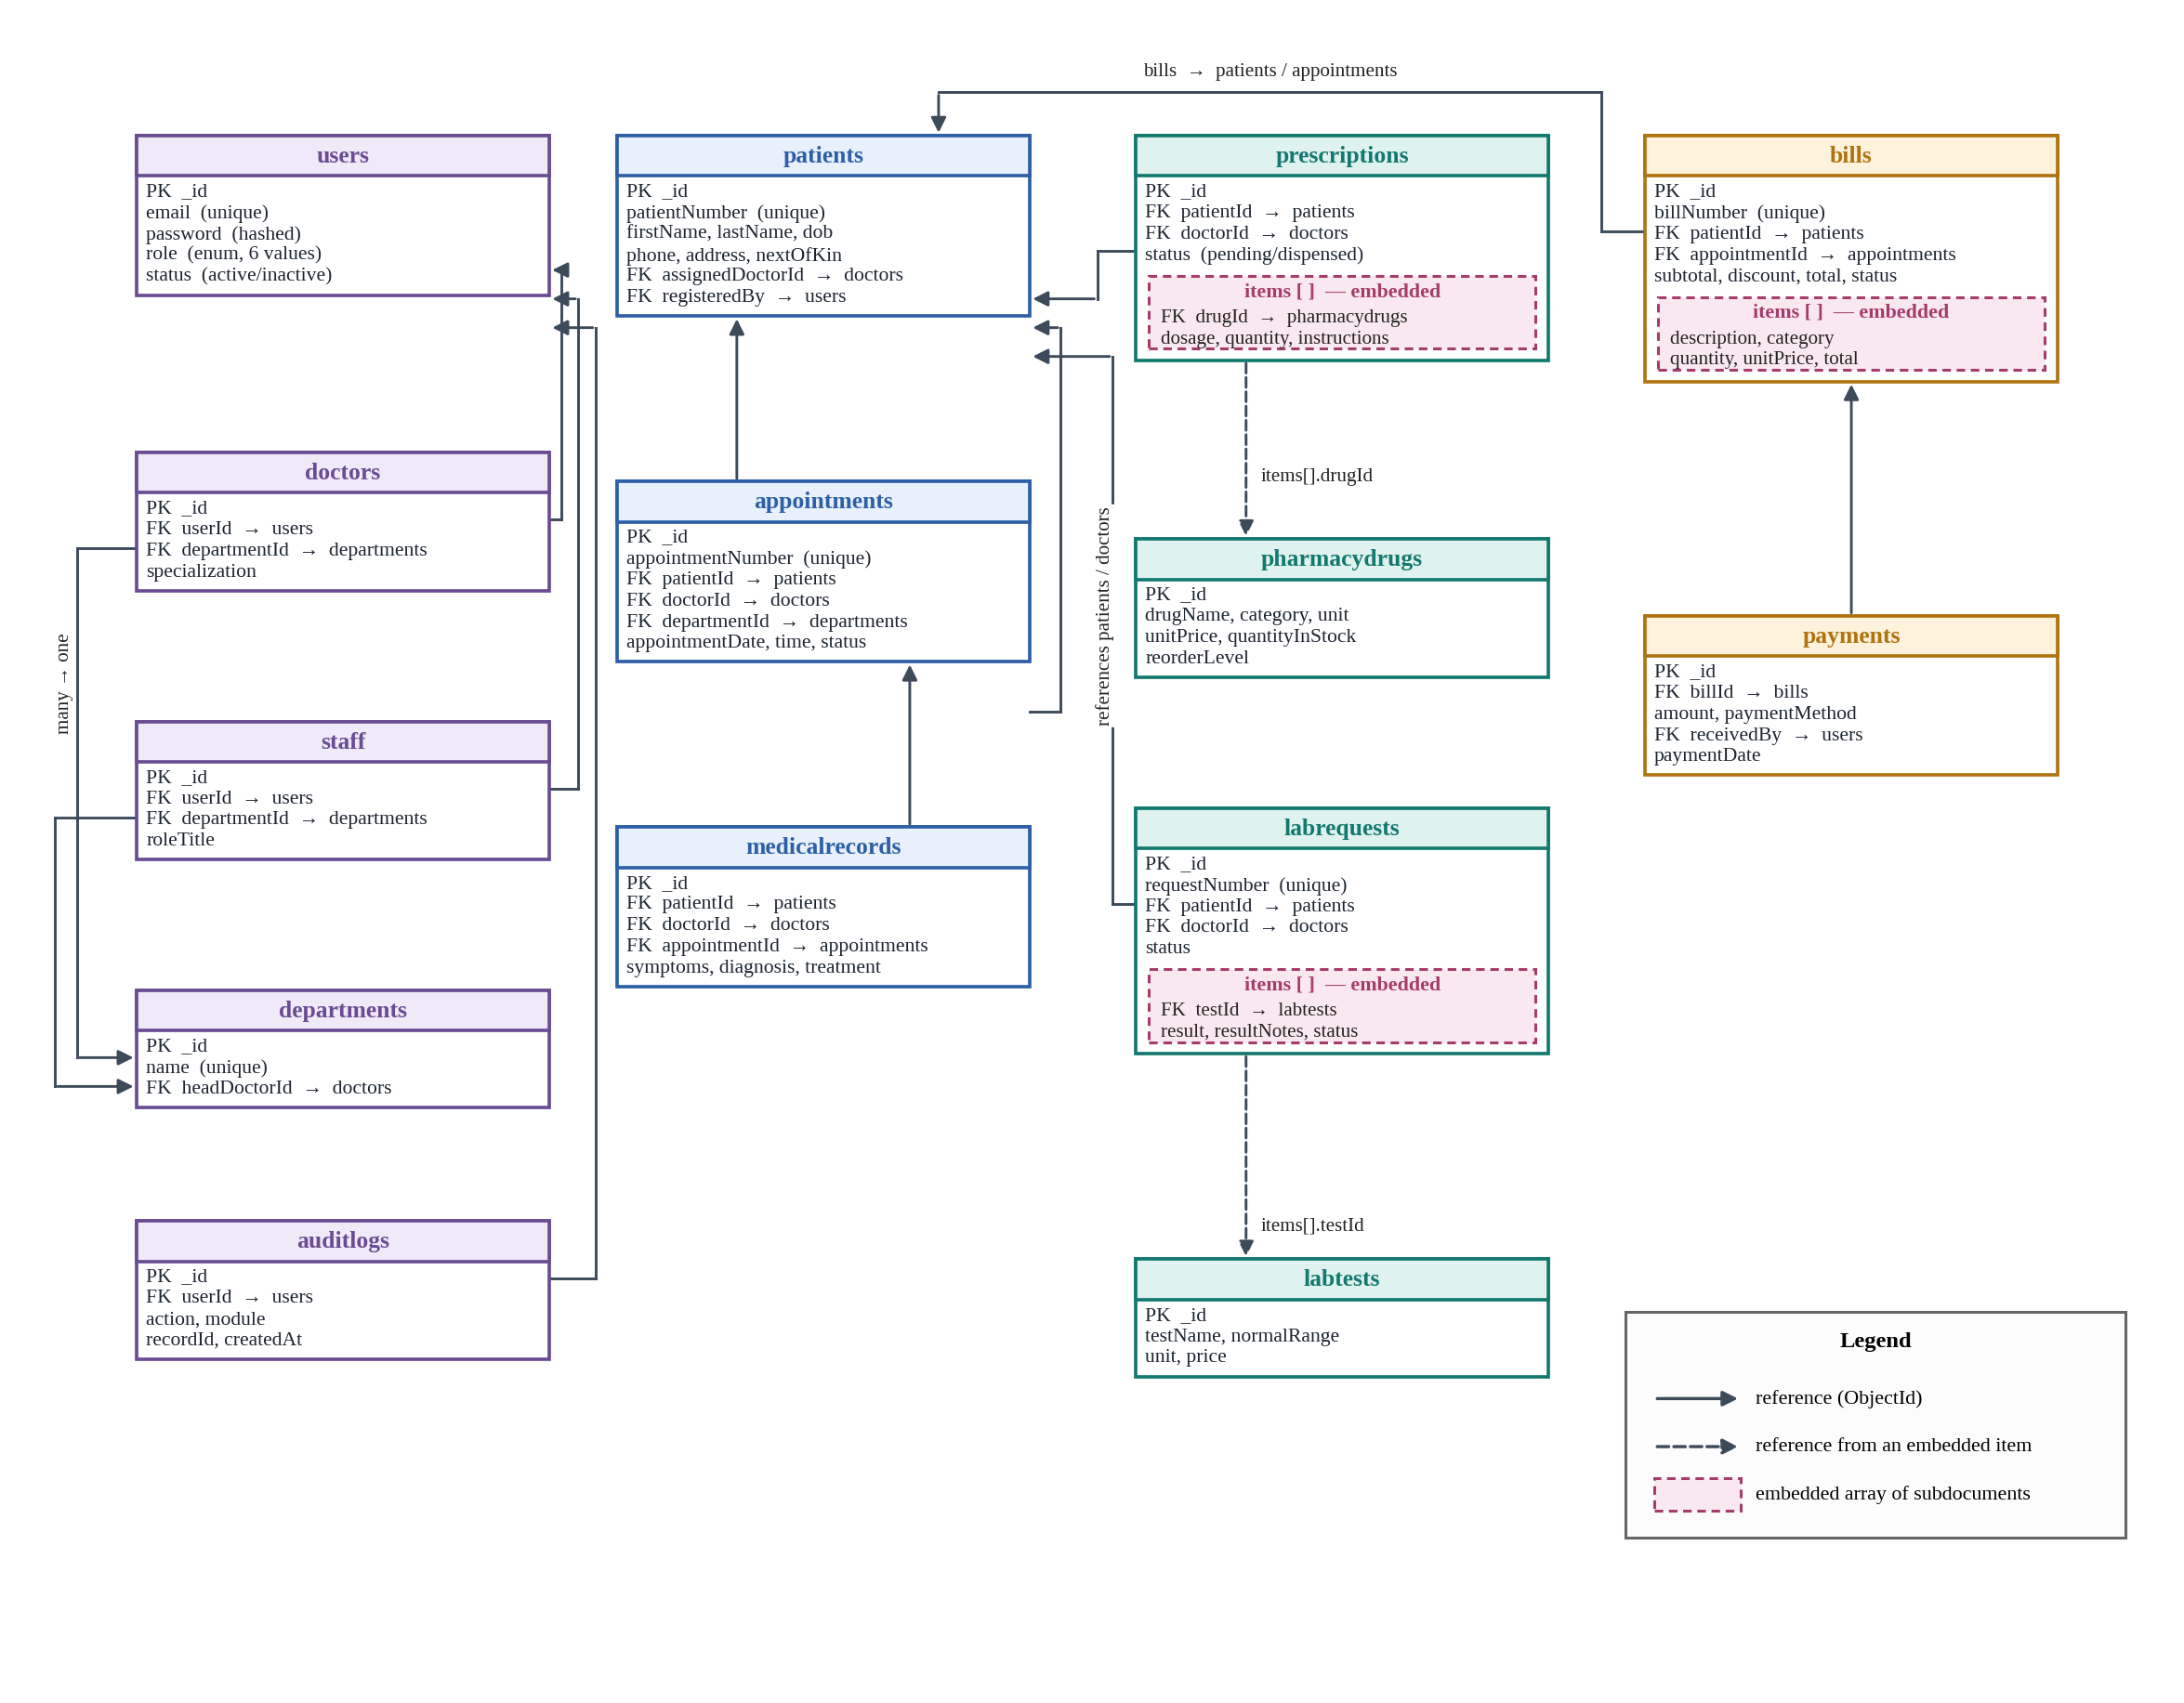
Figure 3.9: Database schema diagram of the proposed system

